**Module 4 Activity 1: Protecting Resources**

Naga Sumanth Vema

IFT 554: Middleware Programming & Database Security

Dinesh Sthapit

March 03rd, 2024

**Module 4 Activity 1: Protecting Resources**

Step 1 : Screenshot of terminal showing successful installation of dependencies.

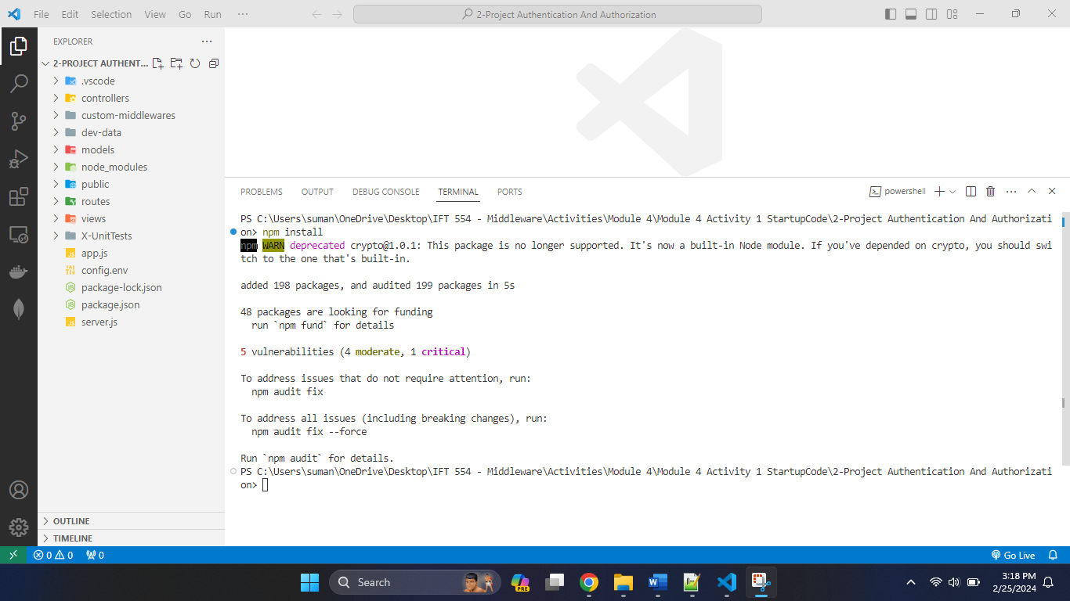

Step 3: Screenshot of Debug Terminal open in VSCode.

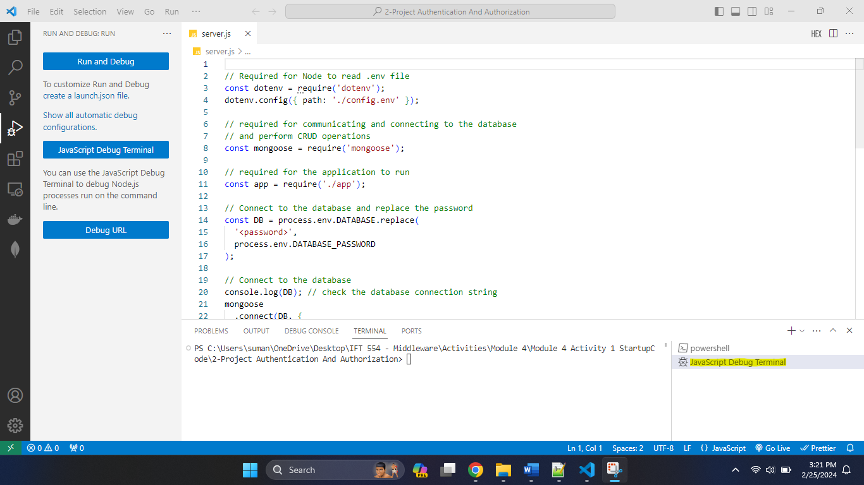

Step 4: Screenshot of Breakpoints set in authMiddleware.js.

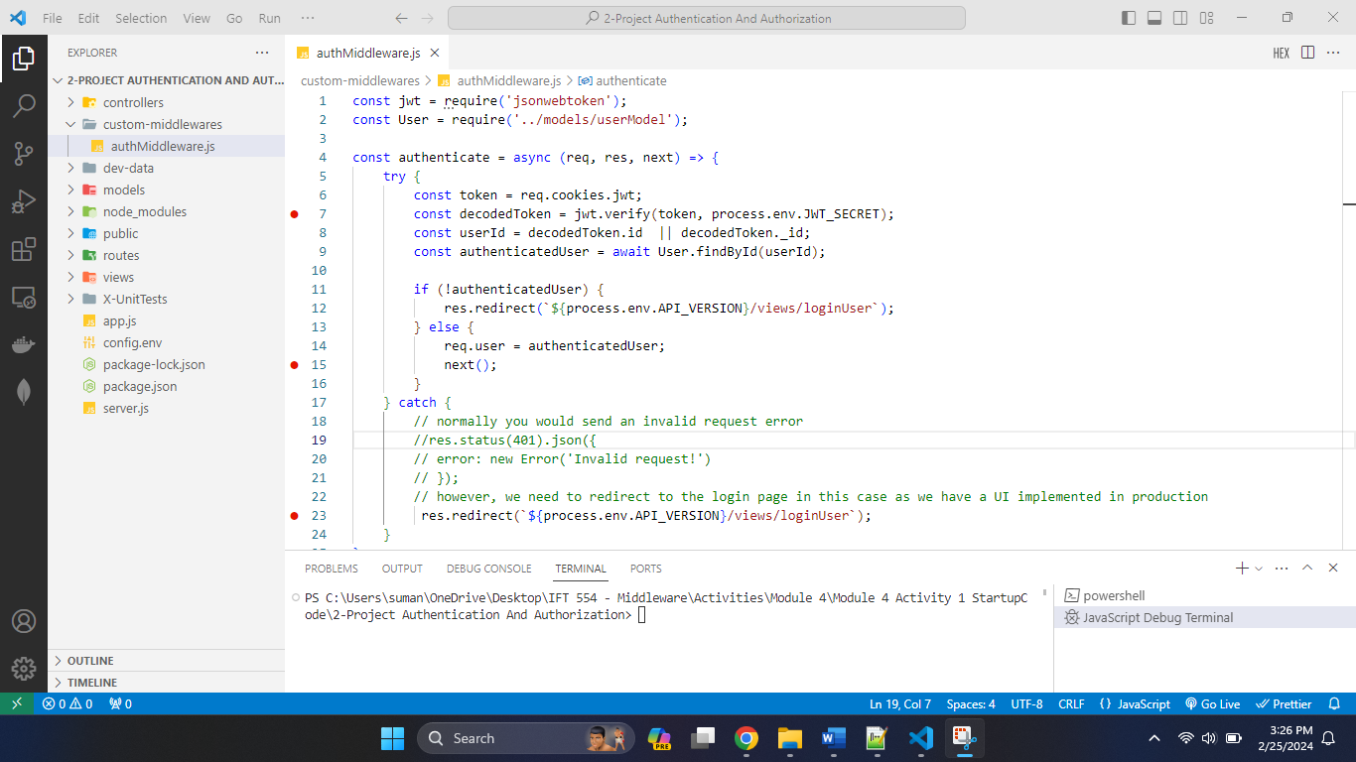

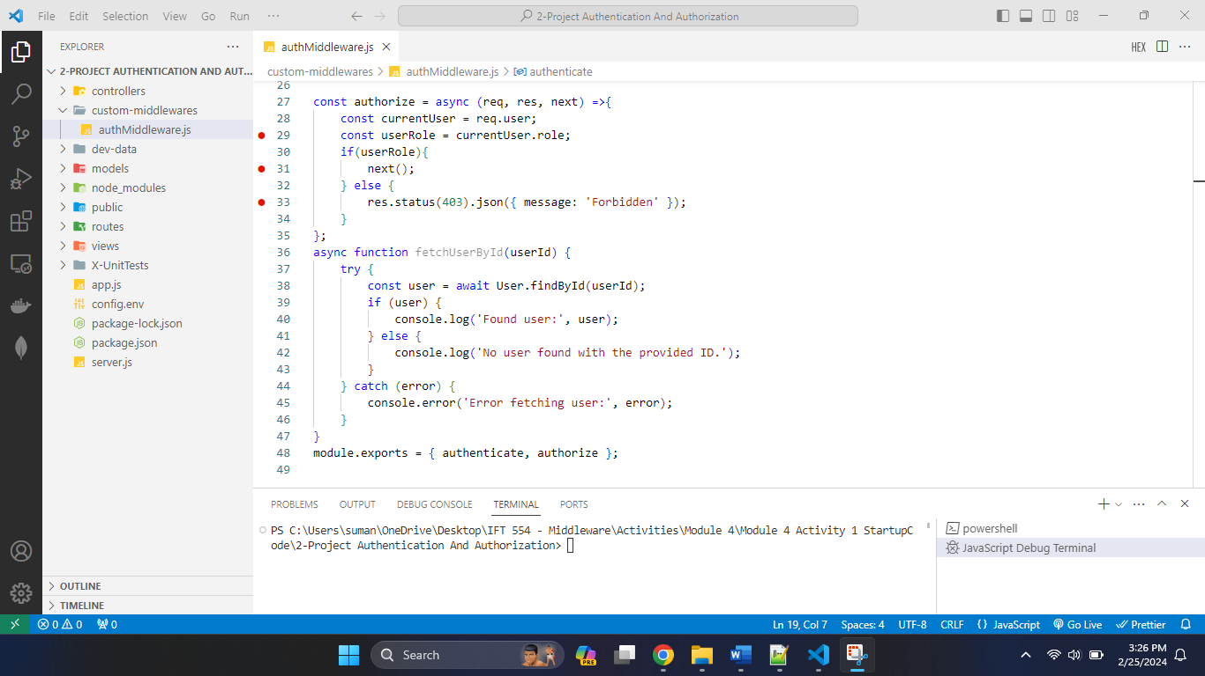

Step 5: Screenshot of "Debugger Attached" message in the terminal.

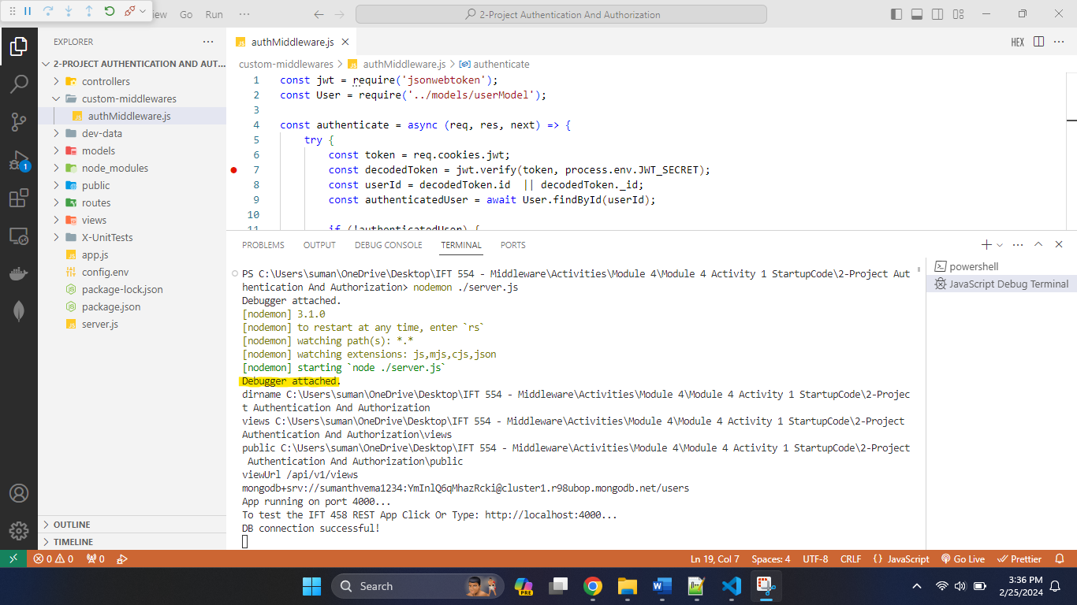

Step 6: Screenshot of Homepage of the application in the browser.

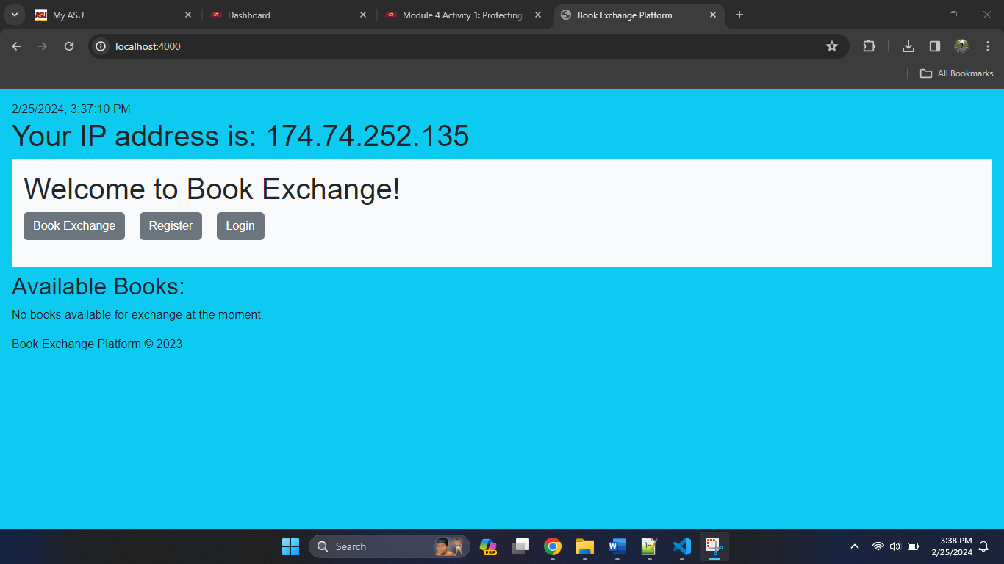

Step 7: Screenshot of the "Add New Book Exchange" page and the login screen.

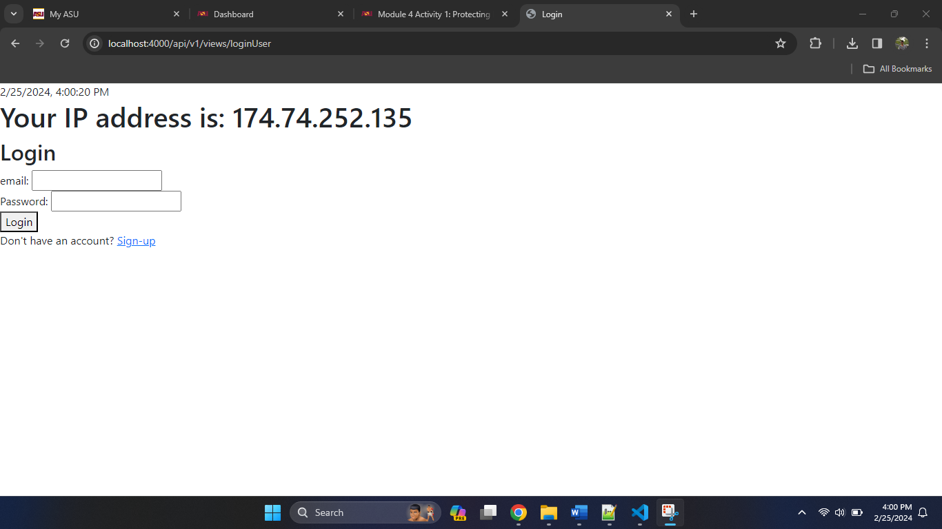

Once the details are entered, clicking on the login button will allows users to login.

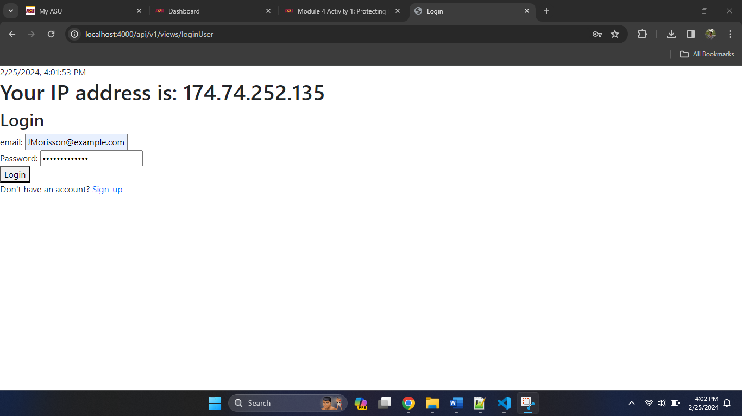

After the authentication is successful, It creates taken for the user and allows the user to access the platform’s features.

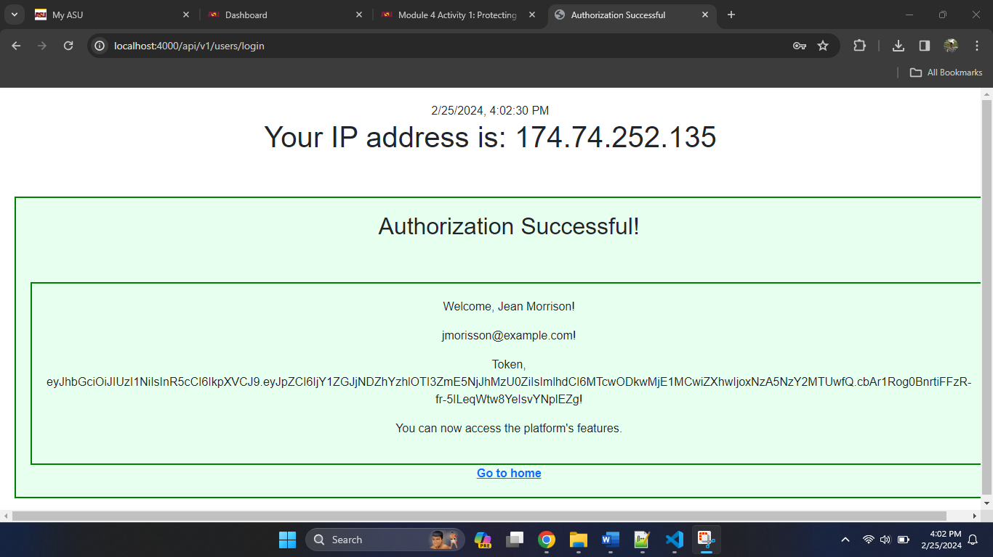

Clicking on Go to home hyperlink will takes me back to home page where I can access the book exchange, register and login features.



Step 8: Screenshot of "Add New Book Exchange" page, indicating access to protected resources.

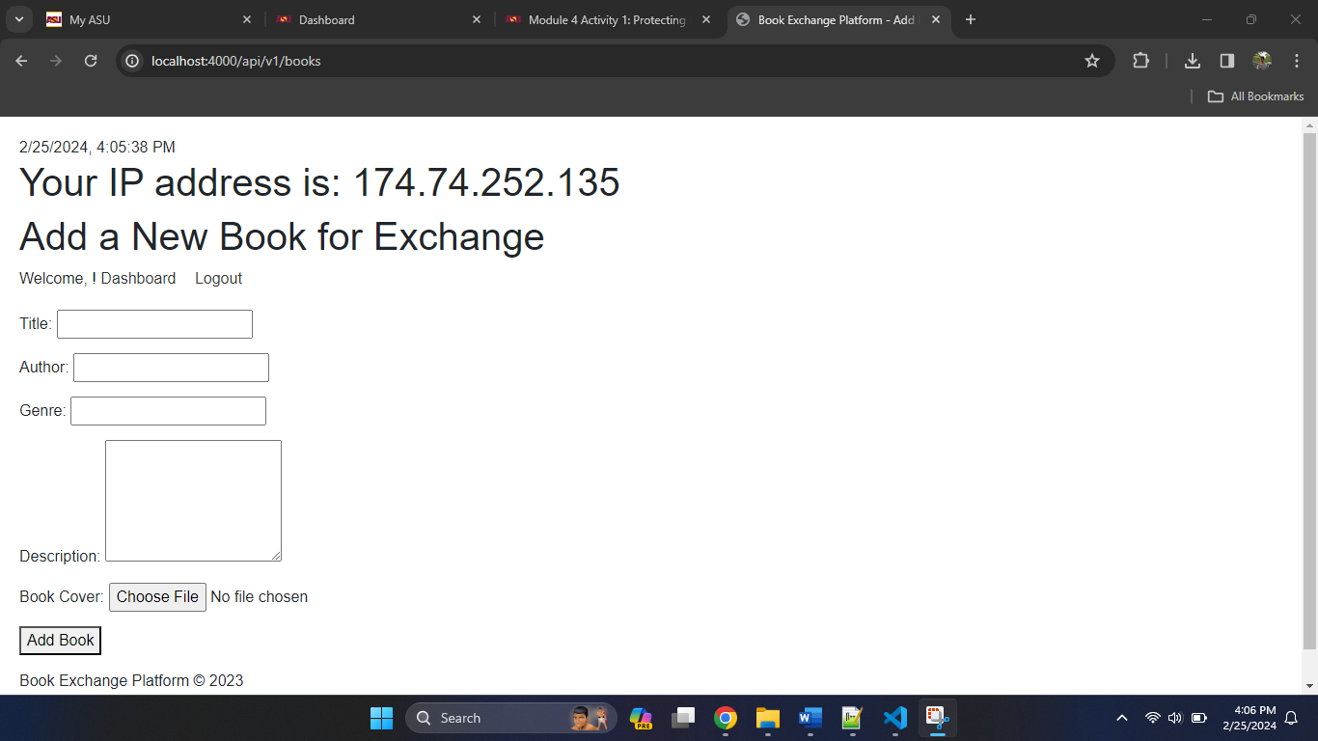

Step 9: Screenshot of terminal confirming the application has been stopped and restarted.

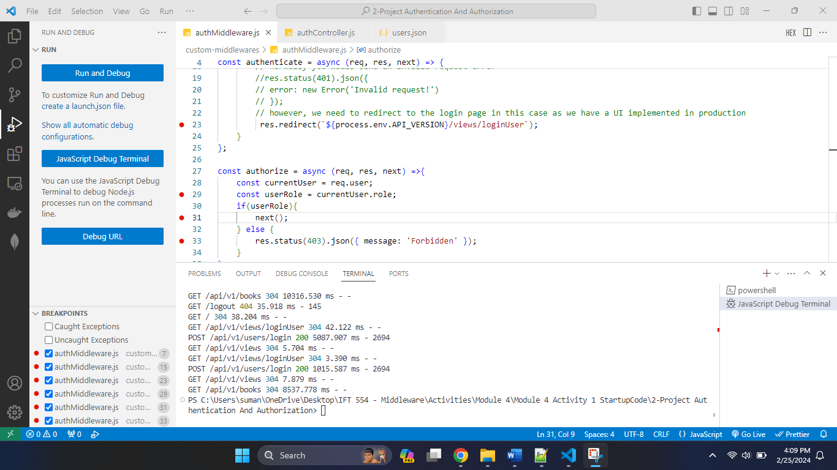

The above screenshot shows that server is stopped using CTRL + C in terminal.

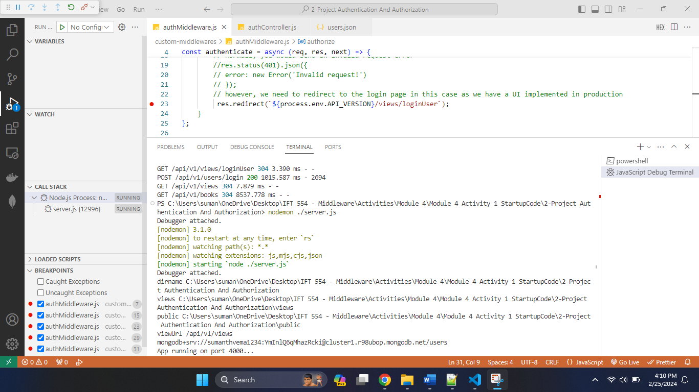

The above screenshot shows that server is restarted using nodemon in terminal.

Screenshot of direct access to the "Add New Book Exchange" UI, showing session persistence.

Clicking on the Book Exchange button redirected to the book exchange page directly.

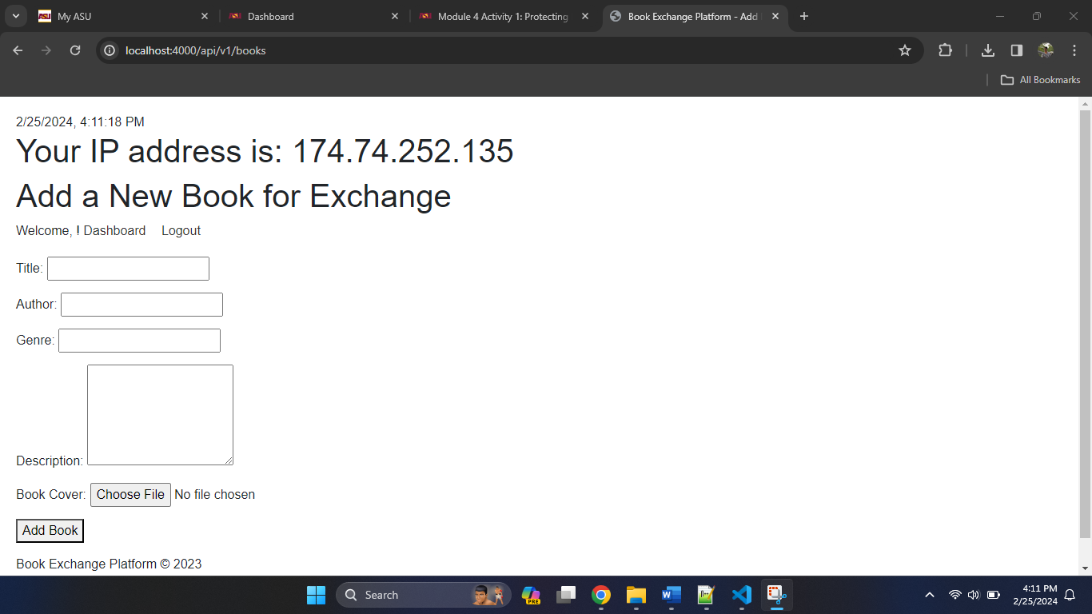

Screenshot of JWT token data and payload verification on jwt.io.

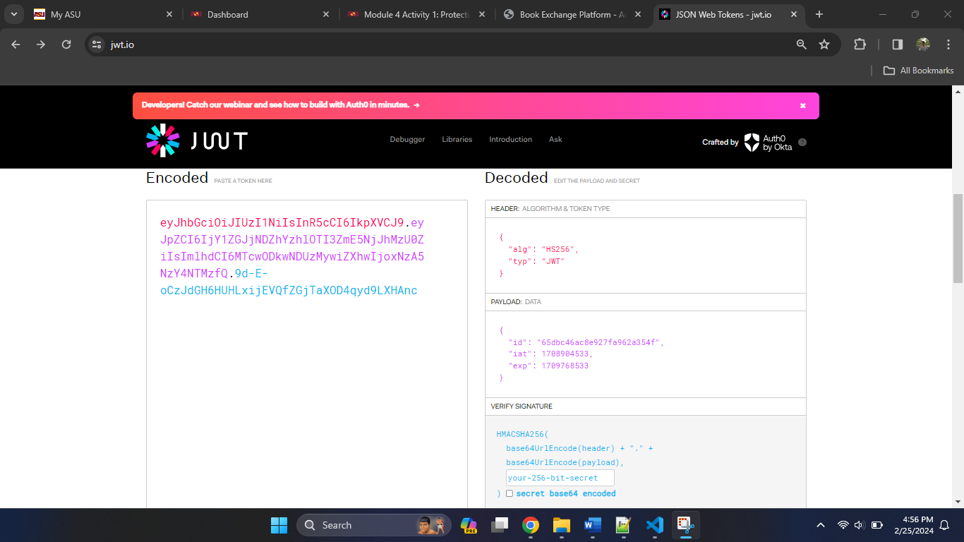

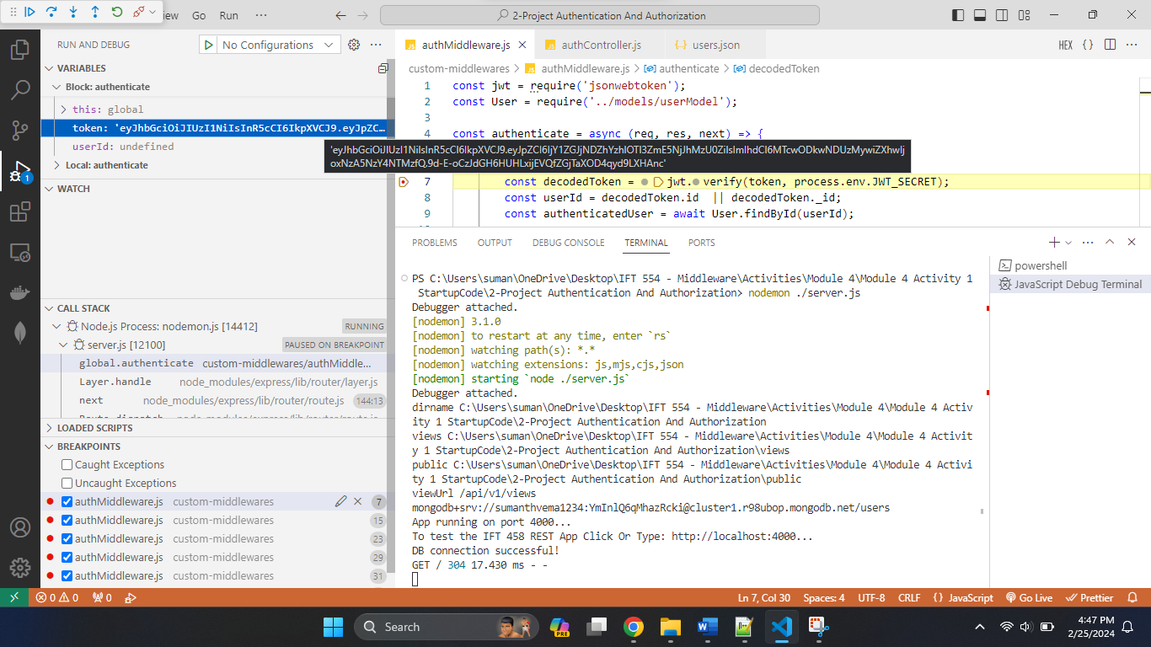

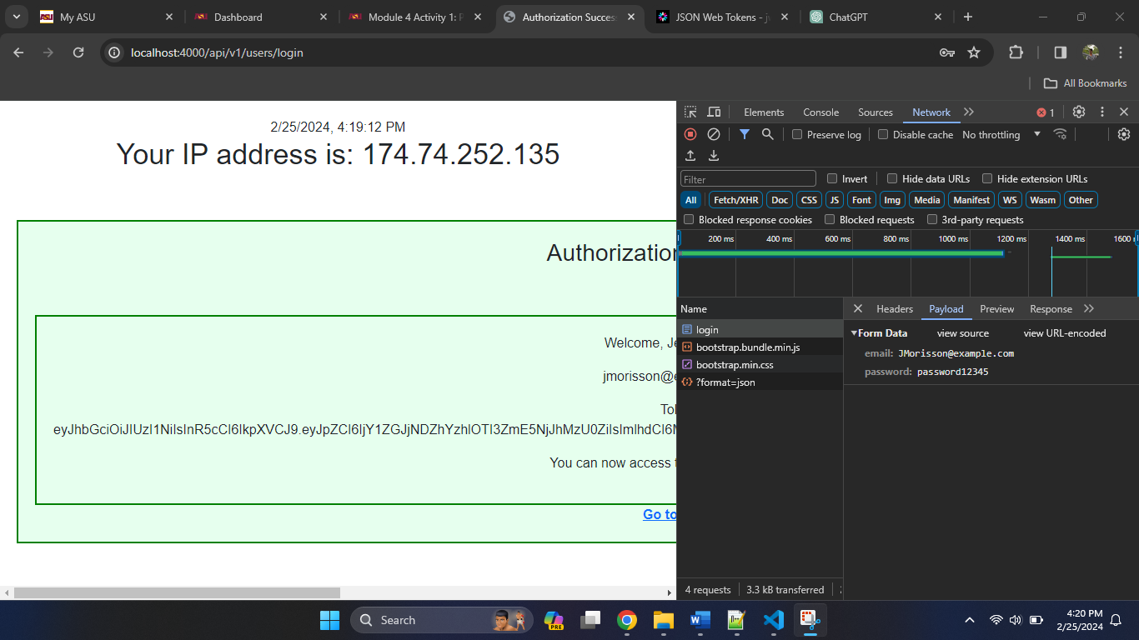

**Process Explanation**

The initial phase showcases the successful installation of dependencies, as evidenced by a terminal screenshot, ensuring a stable foundation for subsequent development tasks. Following this, the configuration of debugging functionalities within Visual Studio Code is illustrated, providing developers with the tools necessary for efficient troubleshooting and analysis. Middleware breakpoints are strategically positioned within the authMiddleware.js file, enabling precise debugging of authentication processes during runtime, as highlighted in the subsequent step displaying the activation of the debugger.

Moving forward, a snapshot of the application's homepage in the browser offers users a glimpse into the interface, serving as the starting point for navigation and interaction. Subsequent screenshots portray the seamless flow of user authentication, with login screens and access to the "Add New Book Exchange" page demonstrating the transition to platform features upon successful authentication. Session creation facilitates continued access, allowing users to navigate back to the homepage and access various functionalities, as indicated by the inclusion of a "Go to home" hyperlink.

Further exploration delves into the protection of resources, with screenshots emphasizing access control measures implemented within the "Add New Book Exchange" page. Administrative capabilities are showcased through terminal screenshots, affirming the application's ability to gracefully stop and restart, a crucial aspect of application management facilitated by tools like nodemon. Additional insights highlight session persistence, enabling users to seamlessly resume interactions without repetitive authentication, and the verification of JWT token data to ensure the integrity of authentication mechanisms.

In essence, this comprehensive documentation encapsulates the iterative development process of the book exchange website, emphasizing the integration of essential components and the adherence to best practices in web application development. Through systematic steps and meticulous attention to detail, the project aims to deliver a robust and user-friendly platform for book enthusiasts to exchange and engage with literary content.